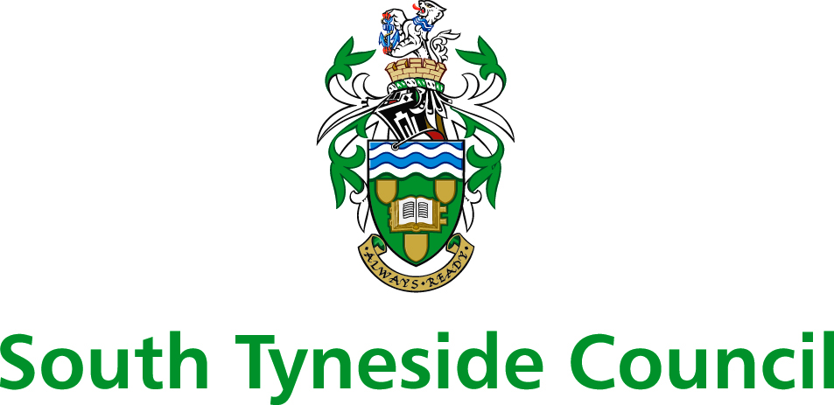

Children, Adults and Health Group
APPLICATION FORM FOR FREE SCHOOL MEALS
This form should be completed in ink or biro and only where parents, or children in their own right, receive one of the beneﬁts listed below.
CAPITAL LETTERS
Surname of Applicant: .............................................. Initials: ............... NI.No..........................................
Address: ..................................................................................................................................................... Tel. No.: ........................................................... Relationship to Pupil(s): .............................DOB..............
1.Set out below the name, date of birth and school etc., of each dependent child who is living at home and is under school leaving age, including children at nursery.

Surname | Forename | Date of Birth | School

2. Your child(ren) will be entitled to receive free school meals if you are in receipt of one of the following beneﬁts:
.Universal Credit (net earnings threshold £7,400 per year)
• Income Support;
• Income Based Jobseekers’ Allowance;
• Income-related employment and support allowance (this benefit was introduced on 27 October 2008)
• Support under Part VI of the Immigration and Asylum Act 1999;
• Your household income does not exceed £16,190 (if you are entitled to Working Tax Credit you will
NOT be eligible for free school meals);
• Guaranteed Element of State Pension Credit.

You must provide proof of entitlement to one of these beneﬁts. Please see overleaf for the
type of proof required.
3. I certify that the information given above is, to the best of my knowledge and belief, correct and I undertake to notify the Council’s Children, Adults and Health Group and my child’s school IMMEDIATELY should my entitlement to beneﬁt cease. I understand that the Children, Adults and Health Group may check the validity of this application.
Signature of Applicant: .................................................................................... Date: ..................................

AN APPLICATION FOR THE PROVISION OF FREE SCHOOL MEALS WAS RECEIVED FROM:
Name of Applicant: ………………………………………………………..……. on …………..………………………..

By: ………………………………………………...…. at: ……………………………………………… office.

Type of proof of entitlement to beneﬁt required:

Universal Credit award statement

Income Support or Income Based Jobseekers’ Allowance or Income-Related ESA
Recent documentation from the Beneﬁts Agency conﬁrming your current entitlement, including your National Insurance Number.

Support under Part VI of the Immigration and Asylum Act 1999
Copy of Identity Card issued.

Guaranteed Element of Pension Credit
Recent documentation from the Beneﬁts Agency conﬁrming current entitlement including your National Insurance Number.

Please return form with proof of entitlement, to: The school your child/children attend

South Tyneside Council is responsible for protecting the public funds it manages. To do this we may use the information you give us on this form, or the information we hold about you to detect and prevent crime or fraud.

